The majority of the progress on the time reversal portion of the self healing project is detailed in our 2012 AIAA SDM conference extended abstract. To summarize, we have been able to use time reversal to focus acoustic wave energy at a defect location. These tests were again performed with rods. This time, however, two rod segments were used instead of just one. Furthermore, we have also performed tests using brass tubes filled with cured epoxy. These tests were in addition to experiments with steel rod segments. In both cases, albeit using slightly different algorithms, we were able to iteratively focus stress-waves at a PZT located between the two rod segments.

One other development that was not mentioned in the AIAA paper deals with noise from the amplifiers used for the experiment. As it is, both the input and output line are attached to their respective PZT so that the PZT is able to both send and receive signals. It was found that even when no signal was being played on a PZT, noise would still be generated by the amplifier which would be read in by the input line on that same PZT. For the steel rod tests this was not much of a problem since the waves propagate so well through the steel. This good transmission meant that the desired signal read in was much greater than the noise produced by the amplifier. With the epoxy rods, however, we found that waves travel much more poorly through the material. As a result, the desired signal read in by the receiving PZT was overshadowed by the noise produced by the amplifier. This is also the reason for having to use the slightly different algorithm for each case. Figure 1 shows the signal read in by the receiving PZT when using epoxy rods and when the input and output lines are connected. Figure 2 shows data from the exact same experiment except with only the input line hooked up to the receiving PZT. As you will see, there is a substantial difference between the data read in.

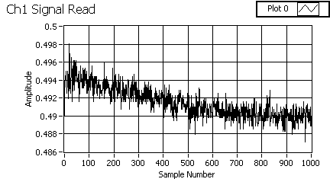

Figure Experimental data from the epoxy rod tests which show the signal read in by the receiving PZT when the input and output lines are connected at the same time

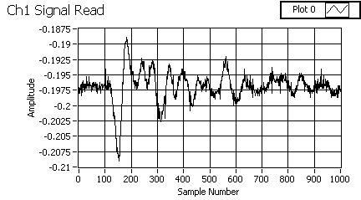

Figure Experimental data from the epoxy rod tests which show the signal read in by the receiving PZT when only the input line is connected to the receiving PZT

A circuit was designed to help with this problem. The circuit consists of two relays for each PZT; one for the positive side line and the other for the negative side line. The PZT is wired to the data input lines ahead of the relay. The data output lines to that PZT are connected behind the relays. When the relays are switched open, the input and output lines for that PZT will be connected and a signal is able to be played out. When the relays are switched off, only the input line remains connected to that particular PZT and no noise is picked up from the amplifier. These relays are controlled via digital outputs from the same program used for the time reversal. The one shortcoming of these is in the fact that the switch is a mechanical movement. As one would quickly guess, this translates to slow on/off transition when compared to the speed of purely electronic switches. This is something that can be improved upon in future designs if needed. As of now, the algorithm for the epoxy tests was modified in such a way as to accommodate this slow transition speed. Figure 3 shows the circuit that was built.

As mentioned in our last report, we were considering a way to manually control the actuators for the mirror project. We are pleased to report that we have made substantial progress on that idea. We have both designed and built a controller in which a user could manually adjust the voltage to 24 different actuator areas by using potentiometers with screw top adjustments. There are two different pieces that go with this setup. The first piece is a potentiometer control board on which the actual adjustments are made. These potentiometers are arranged in the same pattern as the actuator areas on our 24-actuator board. These are shown in Figures 4 and 5.

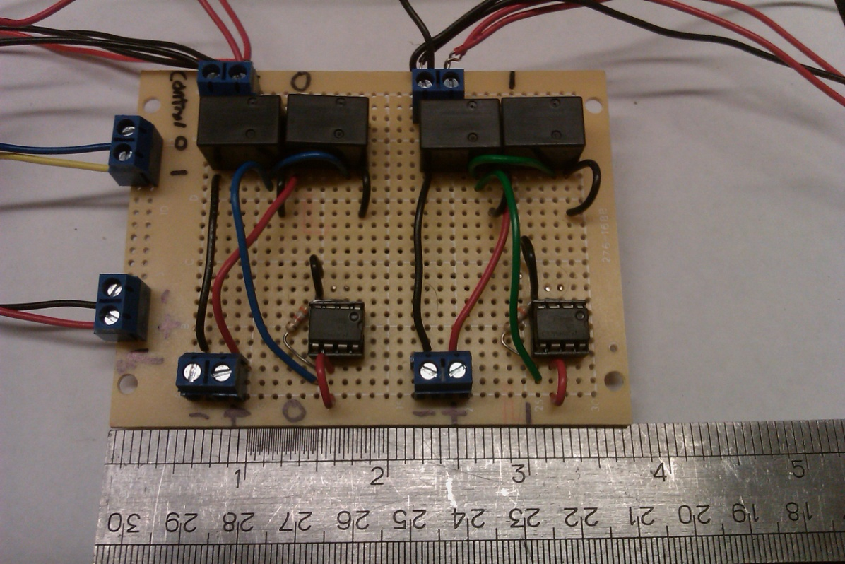

Figure Relay board used for epoxy experiments in order to disconnect the output lines from the PZT so that they do not produce noise on the input lines

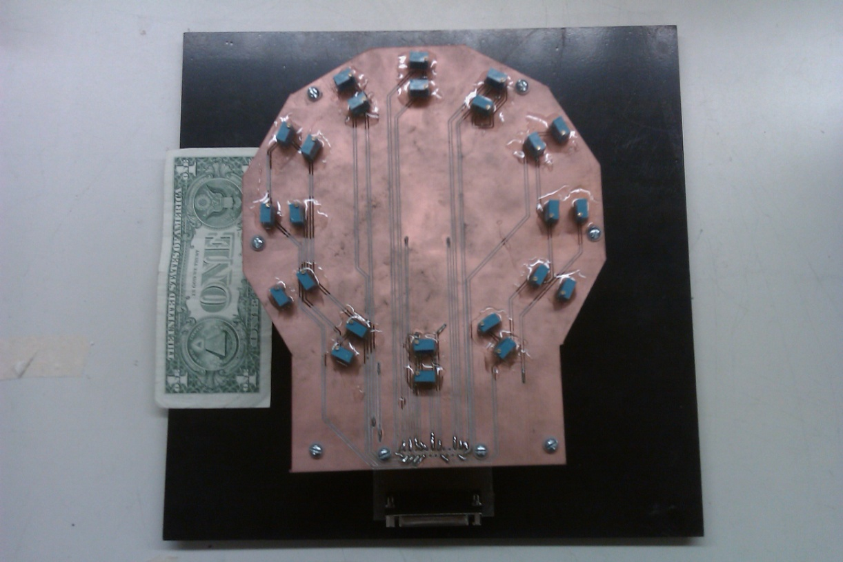

Figure Top view of potentiometer control board

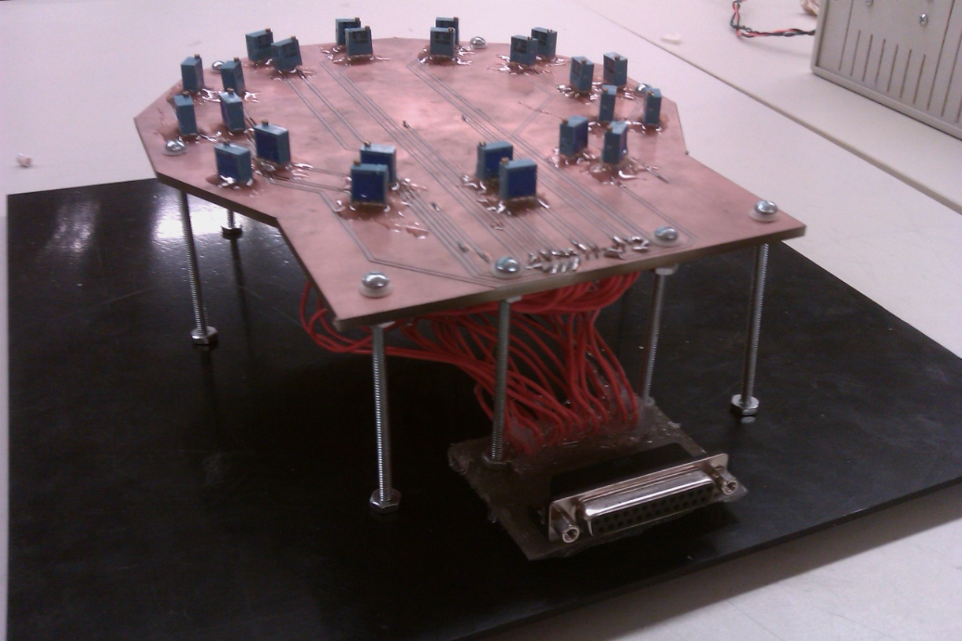

Figure Side view of potentiometer board

The second piece of the setup is a voltage amplifier board. This board has been designed for up to 400V output on each of the 24 channels. The amplifier design is a combination of a simple voltage divider circuit and common emitter amplifier circuit. The control board and voltage board interface using a 25-pin DSUB cord. For each channel, there is a potentiometer on the control board which is in series with a resistor on the amplifier; this forms a voltage divider circuit. As the potentiometer is adjusted, the voltage output from this circuit is adjusted within the range of 0-10V. This voltage output then goes to a unity-gain op amp. The op amp then drives the base current of a BJT configured as a common emitter. This, in turn, produces a voltage output for that channel in the range of 0-400V (when using a 400V input supply for the BJTs). So far, the board has been tested and found to be working with an 18.5V supply, 50V supply, and 250V supply. We have only tested the voltage output from the board at this time. Tests in the very near future will involve controlling a mirror using this setup.

The project box for the voltage amplifier also contains two independently controlled fans. Each fan is controlled by a voltage divider circuit in which one of the resistors is replaced by a thermistor. These thermistors, one for each fan, are attached to long wires in such a way that they can be placed at any location in the project box in order to monitor the temperature at that location. As the thermistor heats up, the fans will turn on and continue to speed up as the temperature rises. They are set to turn off for around 25 degrees Celsius and turn on above that temperature..

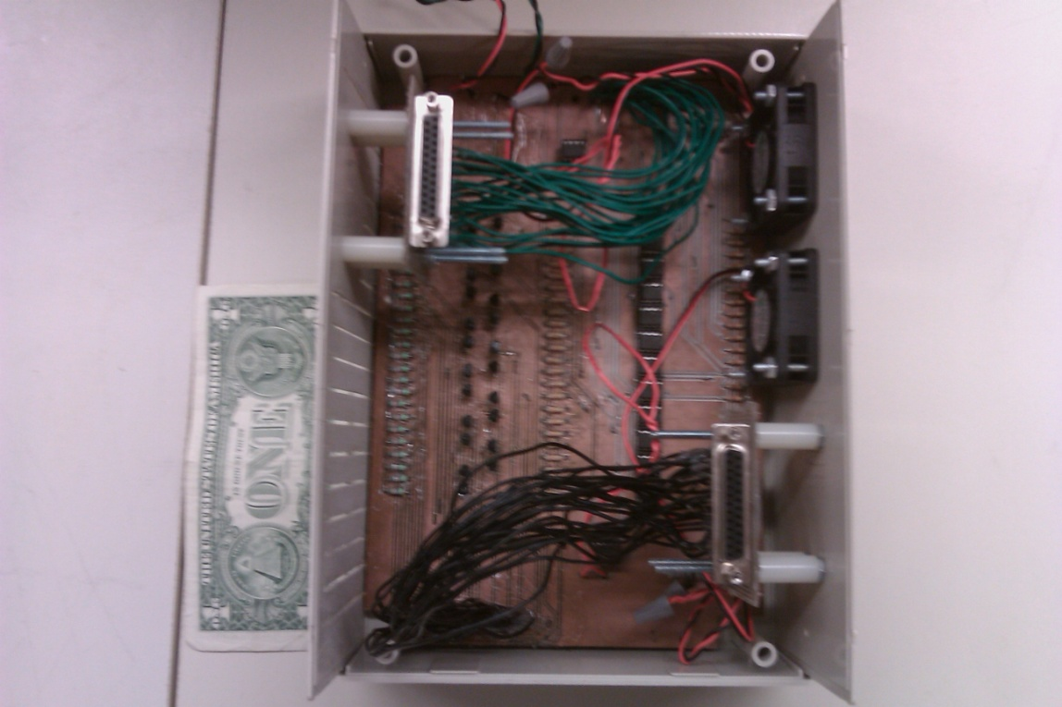

Figure Overhead view of voltage amplifier

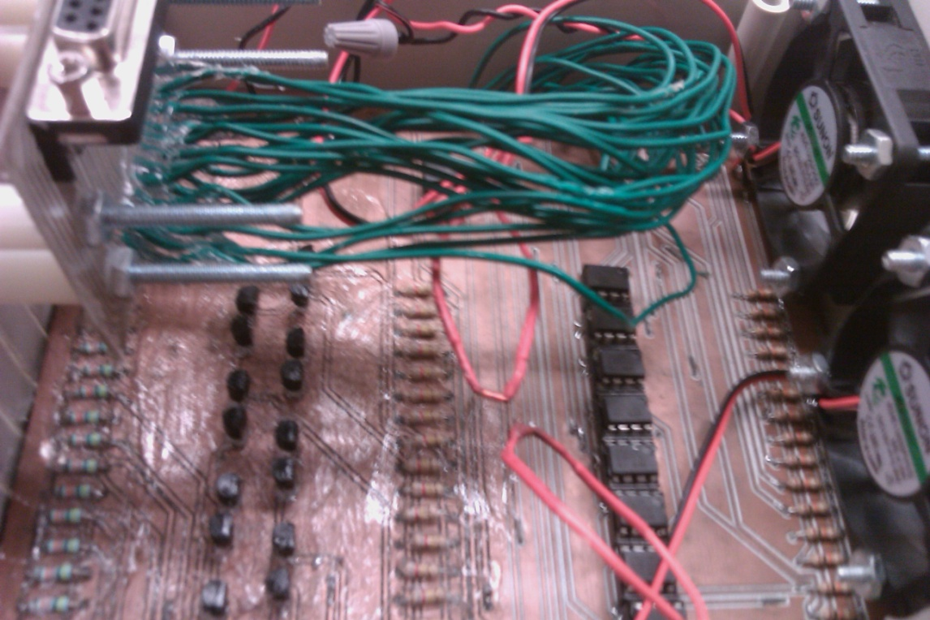

Figure Close up of the input side of the voltage amplifier

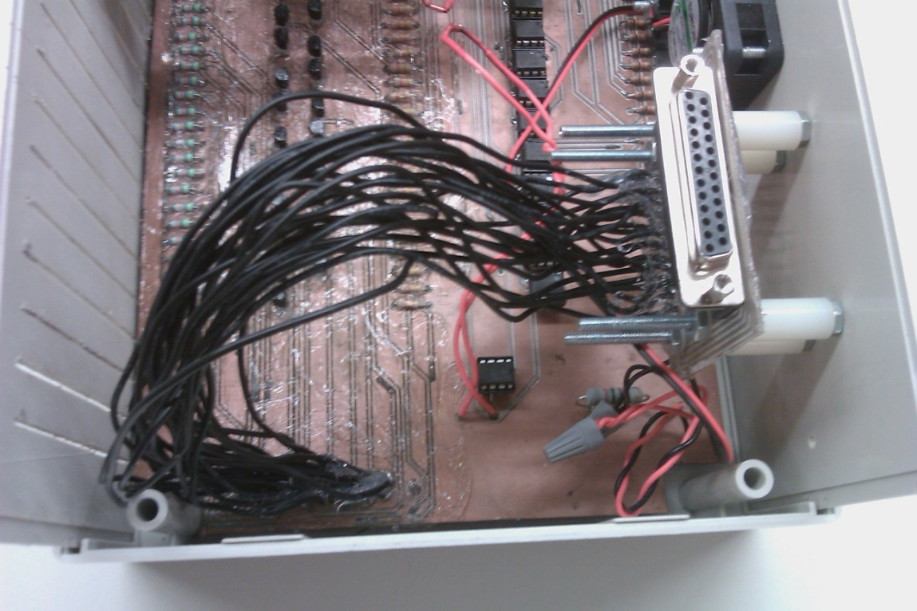

Figure Close up of the output side of the voltage amplifier

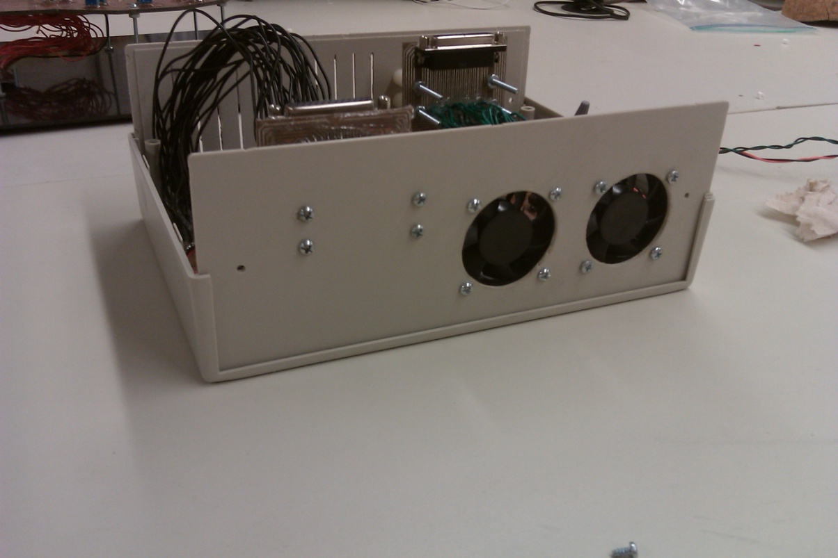

Figure Close up of the fan side of the voltage amplifier

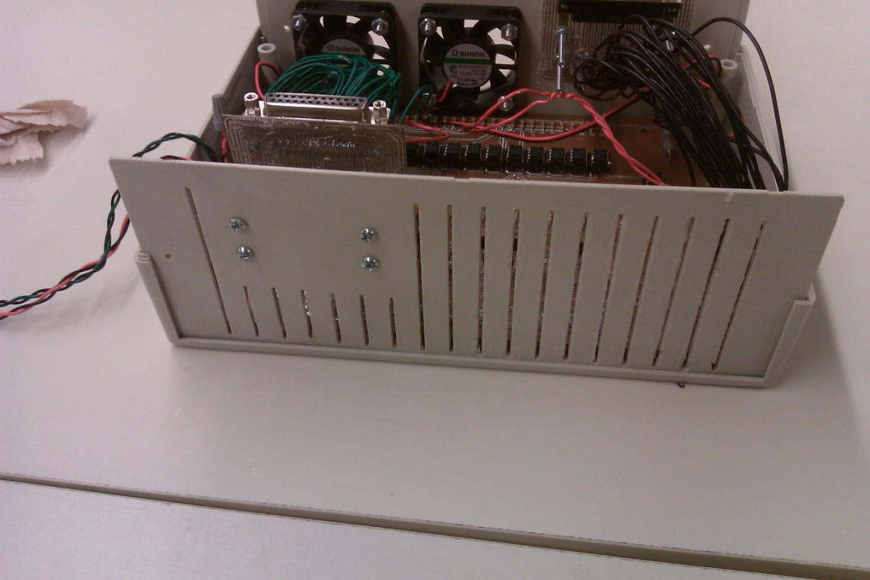

Figure Slotted side of the voltage amplifier

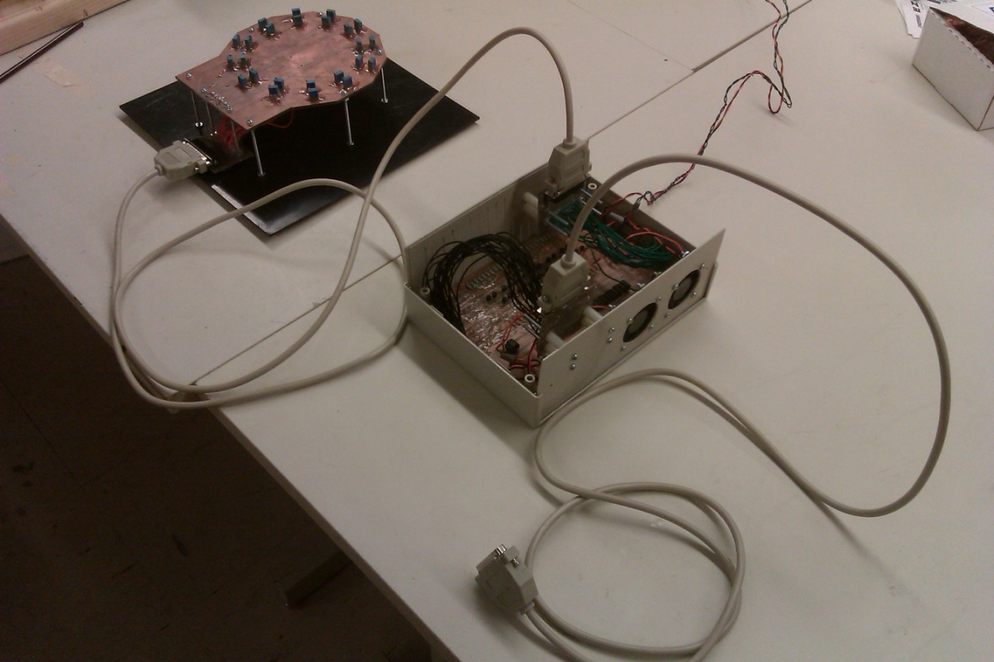

Figure Potentiometer control board connected to the voltage amplifier with a 25-pin DSUB cord